Intellistay

Project Proposal



Supervisor
Dr. Usman Hashmi

Submitted by

Hasan Amin
{01-135222-007}

Essa Babar
{01-135222-004}

Department of Computer Science,
Bahria University, Islamabad.

Introduction

Affordable and convenient accommodation is a growing concern for students and single working professionals, especially in urban areas near universities and workplaces. Existing platforms such as social media groups, unverified brokers, and generic booking sites are often unreliable, unsafe, and lack personalization.

To overcome these issues, IntelliStay introduces a MERN-based web application integrated with AI models to provide a smarter and more reliable accommodation experience. The system allows users to discover verified hostels, apply personalized filters based on budget, location, and facilities, and receive AI-powered cost and budget optimization recommendations that identify the best value-for-money options.

Additionally, IntelliStay enhances user experience through roommate matching based on personality and lifestyle traits, while hostel owners benefit from a dynamic pricing tool and 3D virtual room tours that build trust and improve engagement.

Objectives

The main objectives of the IntelliStay project are as follows:
to design and develop a MERN-based web platform that streamlines hostel discovery and user interaction.

To integrate AI-driven models for:
  - Dynamic pricing for both students and hostel owners.
  - Personality and hostel environment prediction to enhance compatibility.
  - Roommate matching based on personality traits and lifestyle similarities.
  - To provide 3D interactive hostel room tours for an immersive and informed selection experience.
  - To equip hostel owners with analytics dashboards for pricing trends, and performance.
  - To build a secure, transparent, and reliable platform that strengthens trust between students and hostel managers.

Problem Description

Finding suitable and affordable accommodation is a persistent challenge for students and single working professionals. Most existing platforms fail to provide a unified, secure, and personalized solution that considers individual preferences and needs.
The key issues faced by users include:
- Lack of Centralization: Hostel and rental data are scattered across multiple online and offline sources.

- Limited Personalization: Existing systems do not account for users’ budgets, personalities, or lifestyle habits.
- Trust and Security Issues: Listings are often unverified, and payment processes lack safety and transparency.
- Inefficient Management for Owners: Hostel owners lack modern tools for dynamic pricing, analytics, and performance tracking.
Therefore, there is a strong need for an AI-powered, centralized accommodation platform that enhances discovery, personalization, and trust — bridging the gap between students and hostel owners.

Related Work

Several accommodation platforms exist globally, including OLX (Islamabad), HostelWorld, and local hostel operators such as Shaheen Hostels. While these systems provide basic listing and booking services, they lack AI-driven intelligence, personalization, and dynamic optimization features.

For instance, OLX primarily offers informal listings that are unverified and lack structured search or matching algorithms. HostelWorld and similar platforms are geared toward short-term travelers and backpackers, rather than long-term student tenants. Local hostel providers like Shaheen Hostels, although targeted at students, rely on manual management and offer limited analytical or pricing tools.

In contrast, IntelliStay introduces a unified, intelligent solution combining:
- AI-based dynamic pricing for both students and hostel owners,
- Roommate and environment matching using lifestyle and personality data, and
- 3D virtual tours for better hostel visualization.
This integration makes IntelliStay a distinctive and comprehensive platform tailored specifically to the needs of students and professionals.

Feature | IntelliStay (Proposed System) | Existing Systems (OLX, HostelWorld, Shaheen Hostels, etc.)
Target Users | Students and single working professionals seeking verified, long-term, and shared accommodation. | General users, short-term travelers, or tourists; limited focus on students or long-term stays.
Verification & Security | Verified hostel listings. | Often unverified listings; many rely on in-person or cash-based transactions.
Roommate Matching | Matches users based on lifestyle, habits, and personality compatibility using ML clustering. | No roommate matching; users find roommates independently
Dynamic Pricing | Adaptive pricing model for students and owners based on demand, seasonality, and reviews. | Fixed or manually adjusted pricing; no analytics-based optimization.
Hostel Environment Prediction | Uses NLP models to recommend hostels aligned with user personality and lifestyle. | No personality-based or environment-based recommendations
User Personalization | Highly personalized recommendations combining budget, location, and behavioral traits. | Basic search filters like price or distance; no personalized insights.
3D Virtual Tours | Interactive 3D visualization of hostel rooms for better decision-making. | Absent or limited to static images
Owner Dashboard & Analytics | Comprehensive dashboard with occupancy, revenue tracking, and AI-driven insights. | Minimal or no analytics tools; manual management.
Trust & Transparency | Verified listings ensure user confidence. | Varying reliability; lack of centralized verification and secure payment mechanisms.

Proposed Methodology

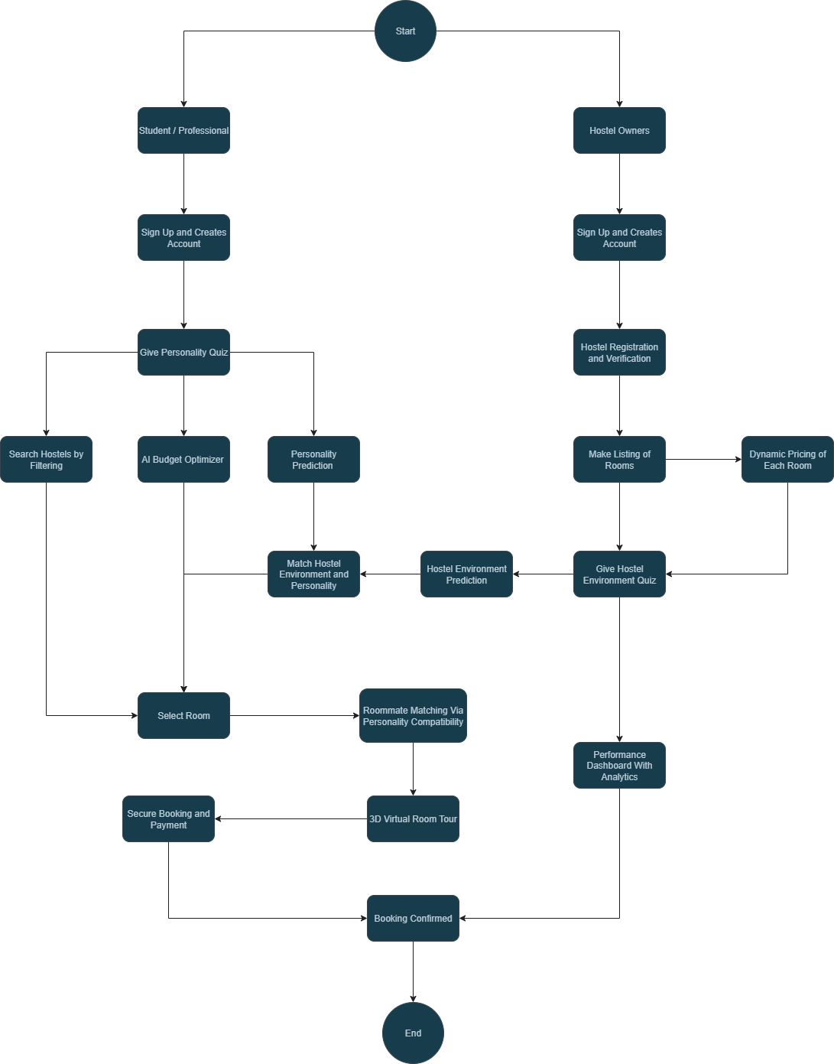
Flow Chart

System Workflow Explanation
The overall workflow of the IntelliStay platform is illustrated in the flowchart above. It demonstrates the interaction between students/professionals, hostel owners, and the AI-driven modules of the system. The process can be explained step-by-step as follows:

- Start
The process begins when a user (student or professional) or a hostel owner initiates the system.

- User Registration
Students/Professionals:
New users sign up and create their accounts to access the system. During registration, they provide basic personal details and accommodation preferences.

Hostel Owners:
Hostel owners also sign up and undergo a verification process to ensure authenticity before listing their hostels.

- Personality and Environment Data Collection
Students/Professionals:
After account creation, users take a personality quiz designed to assess behavioral traits, social preferences, cleanliness habits, and sleep patterns.
Hostel Owners:
Hostel owners complete a hostel environment quiz, describing the hostel’s atmosphere (quiet, social, academic, etc.), amenities, and rules. This data helps in matching hostel environments with user personalities.

- AI Processing and Model Integration
Once the system gathers user and hostel data, multiple AI models are activated:

Personality Prediction Model:
Uses Natural Language Processing (BERT embeddings) to analyze quiz responses and predict each user’s personality profile.
Hostel Environment Prediction Model:
Classifies hostels based on their overall environment and compares them with user personalities.
AI Budget Optimizer:
Applies multi-criteria ranking to suggest hostels that best fit a user’s budget and facility preferences.
Dynamic Pricing Model:
Continuously adjusts room prices for hostel owners based on factors like demand, seasonality, and reviews.

- Search and Matching Process
Students can search hostels manually using filters such as location, budget, and facilities. Simultaneously, the system uses AI to match users with hostels that align with their predicted personality and environmental compatibility.
Roommate Matching:
The system compares personality vectors of users and recommends roommates who are most compatible based on lifestyle and social preferences.

- Hostel Listing and Owner Tools
Hostel owners can list rooms with detailed descriptions and multimedia content. They gain access to: Dynamic pricing suggestions for optimal rent setting and a performance dashboard displaying booking analytics, occupancy rates, and revenue insights.

- Room Selection and Visualization
Once recommendations are displayed, users can select rooms that suit their preferences. Before confirming, they can take a 3D virtual room tour, offering a realistic preview of the hostel space and facilities.

- Booking and Payment
After selecting a suitable room:
Users proceed with secure booking and payment.

- Confirmation and Feedback
The booking is confirmed and recorded in the database. Feedback from users and performance data from hostel owners are collected to enhance AI model accuracy and future recommendations.

- End
The process concludes with a confirmed booking, completing the intelligent accommodation cycle between students and hostel owners.

System Components

- Frontend: Built with React.js, offering a responsive, intuitive interface for students and hostel owners.
- Backend: Developed using Node.js with Express.js, handling RESTful APIs, authentication, and business logic.
- Database: Powered by MongoDB, used to store user profiles, hostel details, reviews, and analytics data.
- AI Microservices: Implemented in Python (FastAPI) for running machine learning and NLP-based models.

AI Models

- Budget Optimizer: Uses multi-criteria ranking to recommend hostels based on user budget, distance, and preferences.
- Roommate Matching: Employs clustering and similarity scoring on lifestyle and personality vectors to find compatible roommates.

- Personality Prediction: Utilizes an NLP-based model (BERT embeddings) to assess user personality from input data.
- Dynamic Pricing: Applies machine learning regression to forecast demand and suggest optimal hostel pricing.
This architecture allows IntelliStay to deliver an efficient, adaptive, and intelligent accommodation experience for both students and hostel owners.

Project Scope

In Scope
- Development of a MERN-based web application for students, hostel owners, and administrators.
- Integration of AI microservices for roommate matching, personality prediction, and dynamic pricing.
- Implementation of 3D virtual room tours for improved hostel visualization.
- Development of analytics dashboards for hostel owners to monitor occupancy and pricing trends

Out of Scope
- Development of mobile applications (React Native).
- Integration of VR technologies for real-time tours.
- Large-scale international deployment.
- Real-time chat or video-based communication modules.

Conclusion

The IntelliStay platform effectively addresses the challenges faced by students and professionals in finding safe, affordable, and compatible accommodation. By combining the MERN stack with AI-powered intelligence, the system offers a unique blend of affordability, personalization, and reliability.
Its core features including dynamic pricing, cost and budget optimization, roommate matching, and 3D virtual tours make it a comprehensive solution that benefits both users and hostel owners. IntelliStay not only enhances transparency and user trust but also sets a new standard for smart, data-driven accommodation systems in academic and urban environments.

References

[1] Airbnb, 'Book unique homes and experiences,' Available: https://www.airbnb.com.
[2] Booking.com, 'Hotels and accommodations,' Available: https://www.booking.com.
[3] HostelWorld, 'Hostels and budget accommodation worldwide,' Available: https://www.hostelworld.com.
[4] Facebook Marketplace, 'Accommodation Groups,' Available: https://www.facebook.com/marketplace/.
[5] HuggingFace, 'Transformers: BERT for NLP,' Available: https://huggingface.co/transformers/.
[6] MongoDB, 'Official Documentation,' Available: https://www.mongodb.com/docs/.

